Day 29 - 104608492 - Shirisha Perapagu

AWS DynamoDB

Task 1:

1. Root user AWS Account created
2. SDK Installed
3. NoSQl workbench - DynamoDB installed

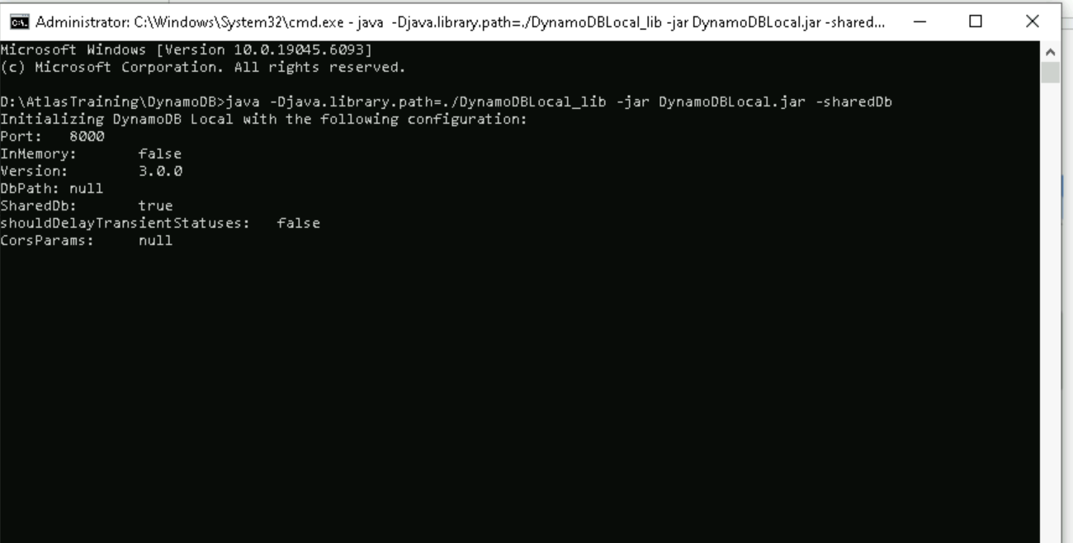

Task 2:

Create a table in NoSQL workbench – DynamoDB

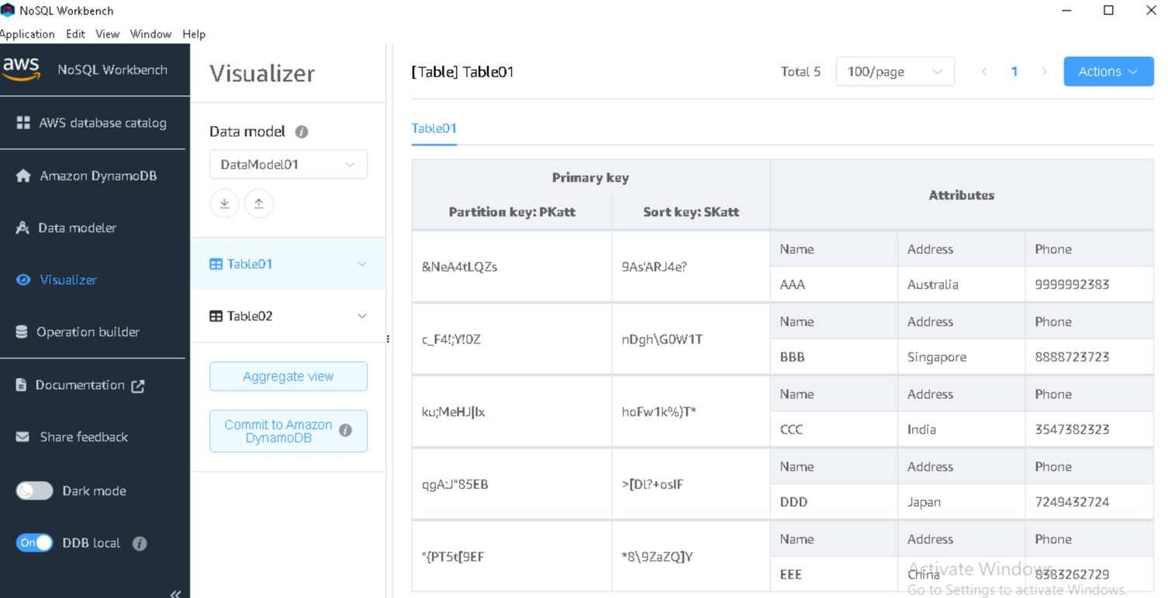

Task 3:

Create different connections with different nos and see if it works … (also commit table to the DynamoDB

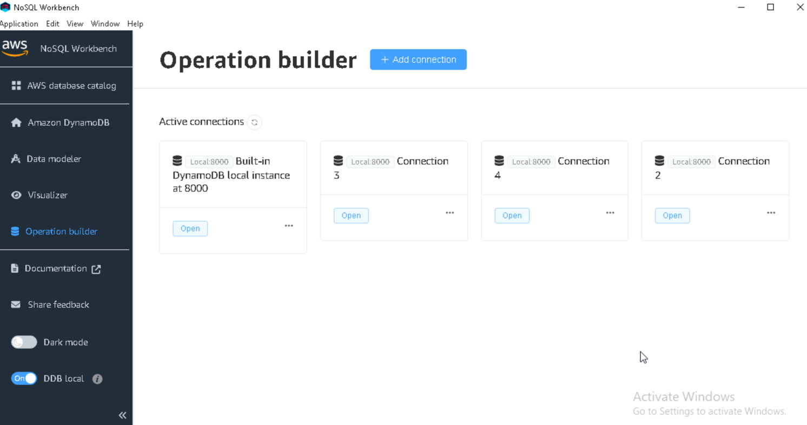

Task 4

AWS CLI

Installed but not working.

